Lab 06 – Worksheet

Name: Mohammad Husain Naqvi | ID: 11062 | Section: T-4

Note: Assumptions and logics should be explained separately in tasks after the task results.

Task 1
Block Diagrams
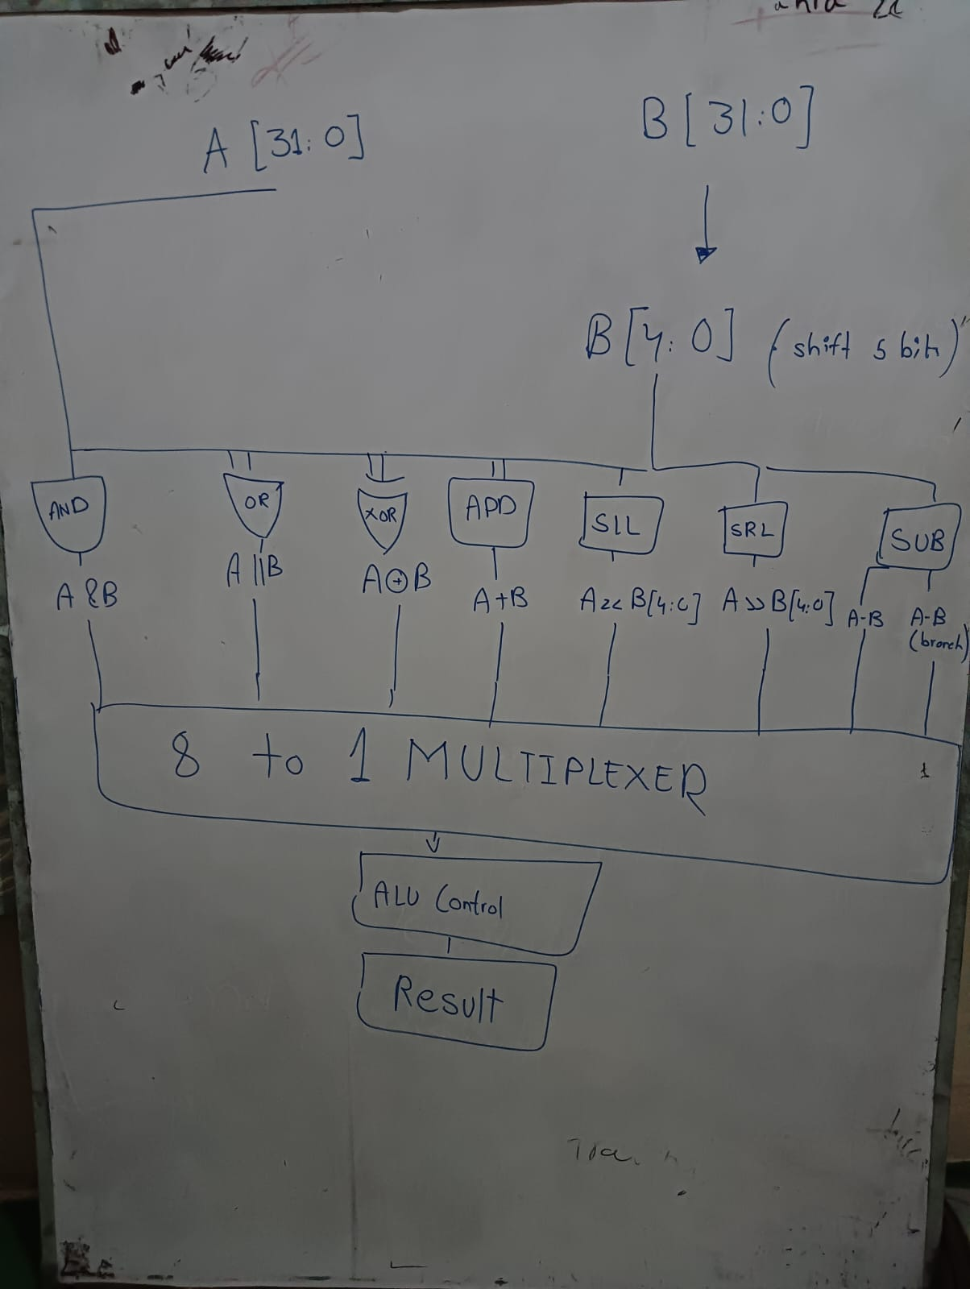

Comments

Task 2

Modules + Testbench:
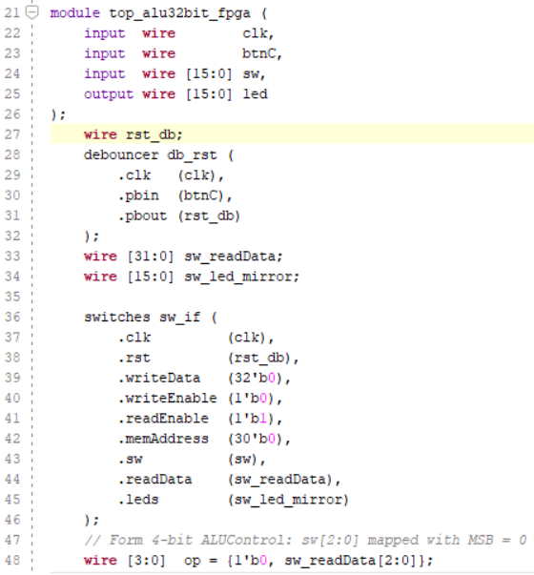
TOP Module:

\

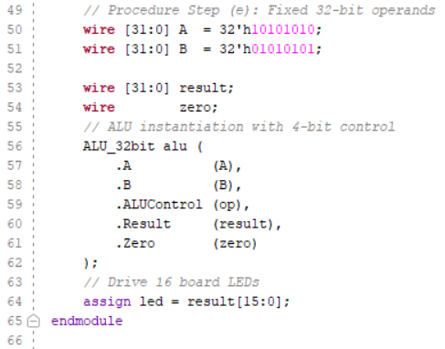

`timescale 1ns / 1ps
////////////////////////////////////////////////////////////////////////////////////
//// Company:
//// Engineer:
////
//// Create Date: 08.10.2026 13:36:04
//// Design Name:
//// Module Name: ALUtop
//// Project Name:
//// Target Devices:
//// Tool Versions:
//// Description: A
////
//// Dependencies:
////
//// Revision:
//// Revision 0.01 - File Created
//// Additional Comments:
////
////////////////////////////////////////////////////////////////////////////////////
module top_alu32bit_fpga (
input wire clk,
input wire btnC,
input wire [15:0] sw,
output wire [15:0] led
);
wire rst_db;
debouncer db_rst (
.clk (clk),
.pbin (btnC),
.pbout (rst_db)
);
wire [31:0] sw_readData;
wire [15:0] sw_led_mirror;

switches sw_if (
.clk (clk),
.rst (rst_db),
.writeData (32'b0),
.writeEnable (1'b0),
.readEnable (1'b1),
.memAddress (30'b0),
.sw (sw),
.readData (sw_readData),
.leds (sw_led_mirror)
);
// Form 4-bit ALUControl: sw[2:0] mapped with MSB = 0
wire [3:0] op = {1'b0, sw_readData[2:0]};
// Procedure Step (e): Fixed 32-bit operands
wire [31:0] A = 32'h10101010;
wire [31:0] B = 32'h01010101;

wire [31:0] result;
wire zero;
// ALU instantiation with 4-bit control
ALU_32bit alu (
.A (A),
.B (B),
.ALUControl (op),
.Result (result),
.Zero (zero)
);
// Drive 16 board LEDs
assign led = result[15:0];
endmodule

ALU :

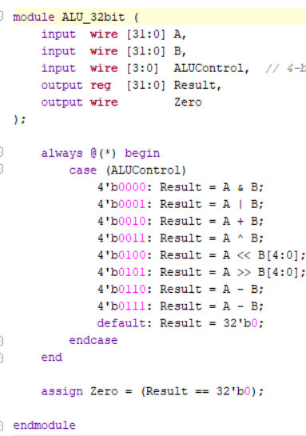

`timescale 1ns / 1ps
//////////////////////////////////////////////////////////////////////////////////
// Company:
// Engineer:
//
// Create Date: 08.10.2026 02:54:14
// Design Name:
// Module Name: acsd
// Project Name:
// Target Devices:
// Tool Versions:
// Description:
//
// Dependencies:
//
// Revision:
// Revision 0.01 - File Created
// Additional Comments:
//
//////////////////////////////////////////////////////////////////////////////////

module ALU_32bit (
input wire [31:0] A,
input wire [31:0] B,
input wire [3:0] ALUControl, // 4-bit ALU control
output reg [31:0] Result,
output wire Zero
);

always @(*) begin
case (ALUControl)
4'b0000: Result = A & B; // AND (Switches: None) -> 0x0000
4'b0001: Result = A | B; // OR (Switches: 0) -> 0x1111
4'b0010: Result = A + B; // ADD (Switches: 1) -> 0x1111
4'b0011: Result = A ^ B; // XOR (Switches: 0, 1) -> 0x1111
4'b0100: Result = A << B[4:0]; // SLL (Switches: 2) -> 0x2020
4'b0101: Result = A >> B[4:0]; // SRL (Switches: 0, 2) -> 0x0808
4'b0110: Result = A - B; // SUB (Switches: 1, 2) -> 0x0F0F
4'b0111: Result = A - B; // BEQ (Switches: 0, 1, 2) -> 0x0F0F
default: Result = 32'b0;
endcase
end

assign Zero = (Result == 32'b0);

endmodule

Debouncer:

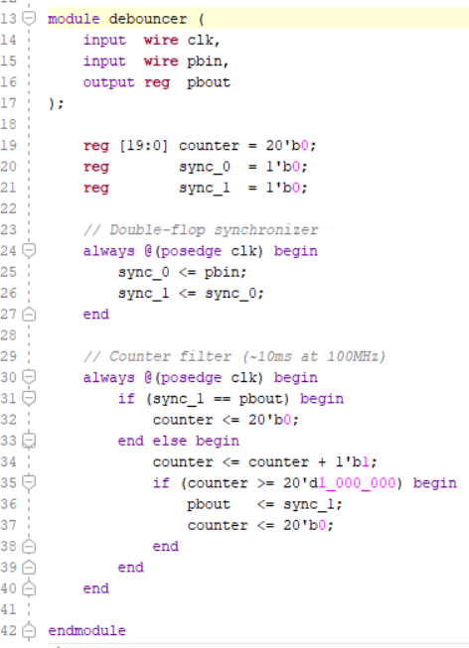

`timescale 1ns / 1ps
//////////////////////////////////////////////////////////////////////////////////
// Company:
// Engineer: Muddassir Ali

// Module Name: debouncer
// Project Name: Counter
// Target Devices: Baasys 3
//
//////////////////////////////////////////////////////////////////////////////////

module debouncer (
input wire clk,
input wire pbin,
output reg pbout
);

reg [19:0] counter = 20'b0;
reg sync_0 = 1'b0;
reg sync_1 = 1'b0;

// Double-flop synchronizer
always @(posedge clk) begin
sync_0 <= pbin;
sync_1 <= sync_0;
end

// Counter filter (~10ms at 100MHz)
always @(posedge clk) begin
if (sync_1 == pbout) begin
counter <= 20'b0;
end else begin
counter <= counter + 1'b1;
if (counter >= 20'd1_000_000) begin
pbout <= sync_1;
counter <= 20'b0;
end
end
end

endmodule

SWITHCES:
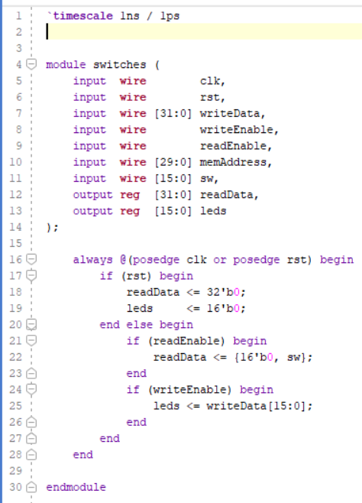

`timescale 1ns / 1ps

module switches (
input wire clk,
input wire rst,
input wire [31:0] writeData,
input wire writeEnable,
input wire readEnable,
input wire [29:0] memAddress,
input wire [15:0] sw,
output reg [31:0] readData,
output reg [15:0] leds
);

always @(posedge clk or posedge rst) begin
if (rst) begin
readData <= 32'b0;
leds <= 16'b0;
end else begin
if (readEnable) begin
readData <= {16'b0, sw};
end
if (writeEnable) begin
leds <= writeData[15:0];
end
end
end

endmodule

TESTBENCH:

`timescale 1ns / 1ps

module ALU_tb;

reg [31:0] A;
reg [31:0] B;
reg [3:0] ALUControl;
wire [31:0] Result;
wire Zero;

ALU_32bit uut (
.A (A),
.B (B),
.ALUControl (ALUControl),
.Result (Result),
.Zero (Zero)
);

initial begin
// Fixed operands per step (e)
A = 32'h10101010;
B = 32'h01010101;
ALUControl = 4'b0000;
#50;

// 1. AND (0000) -> 0x00000000
ALUControl = 4'b0000;
#50;

// 2. OR (0001) -> 0x11111111
ALUControl = 4'b0001;
#50;

// 3. ADD (0010) -> 0x11111111
ALUControl = 4'b0010;
#50;

// 4. XOR (0011) -> 0x11111111
ALUControl = 4'b0011;
#50;

// 5. SLL (0100) -> 0x20202020
ALUControl = 4'b0100;
#50;

// 6. SRL (0101) -> 0x08080808
ALUControl = 4'b0101;
#50;

// 7. SUB (0110) -> 0x0F0F0F0F
ALUControl = 4'b0110;
#50;

// 8. BEQ (0111) -> 0x0F0F0F0F
ALUControl = 4'b0111;
#50;

// 9. Zero Flag Check (Equal inputs)
A = 32'hA5A5A5A5;
B = 32'hA5A5A5A5;
ALUControl = 4'b0110; // SUB -> Result = 0, Zero = 1
#50;

$finish;
end

endmodule

Results:

Task 3

RTL Schematics
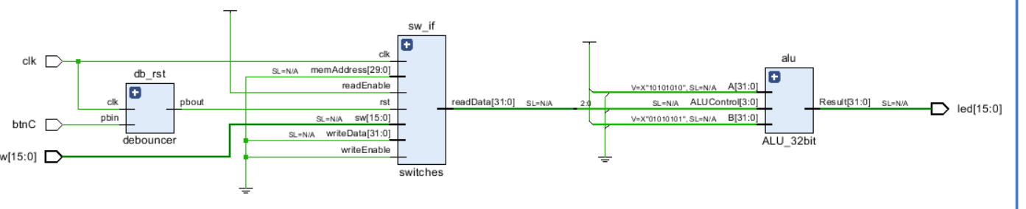
The simulation tests all ALU operations using fixed inputs
A = 0x10101010 (269488144)
B = 0x01010101 (16843009).

AND: ( 0 – 100ns )
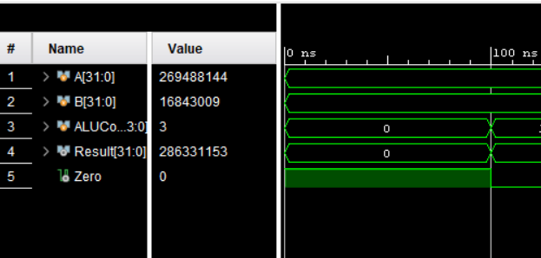

1. AND (ALUControl = 0): Result = 0 (0x00000000). All bits are 0, so Zero flag =

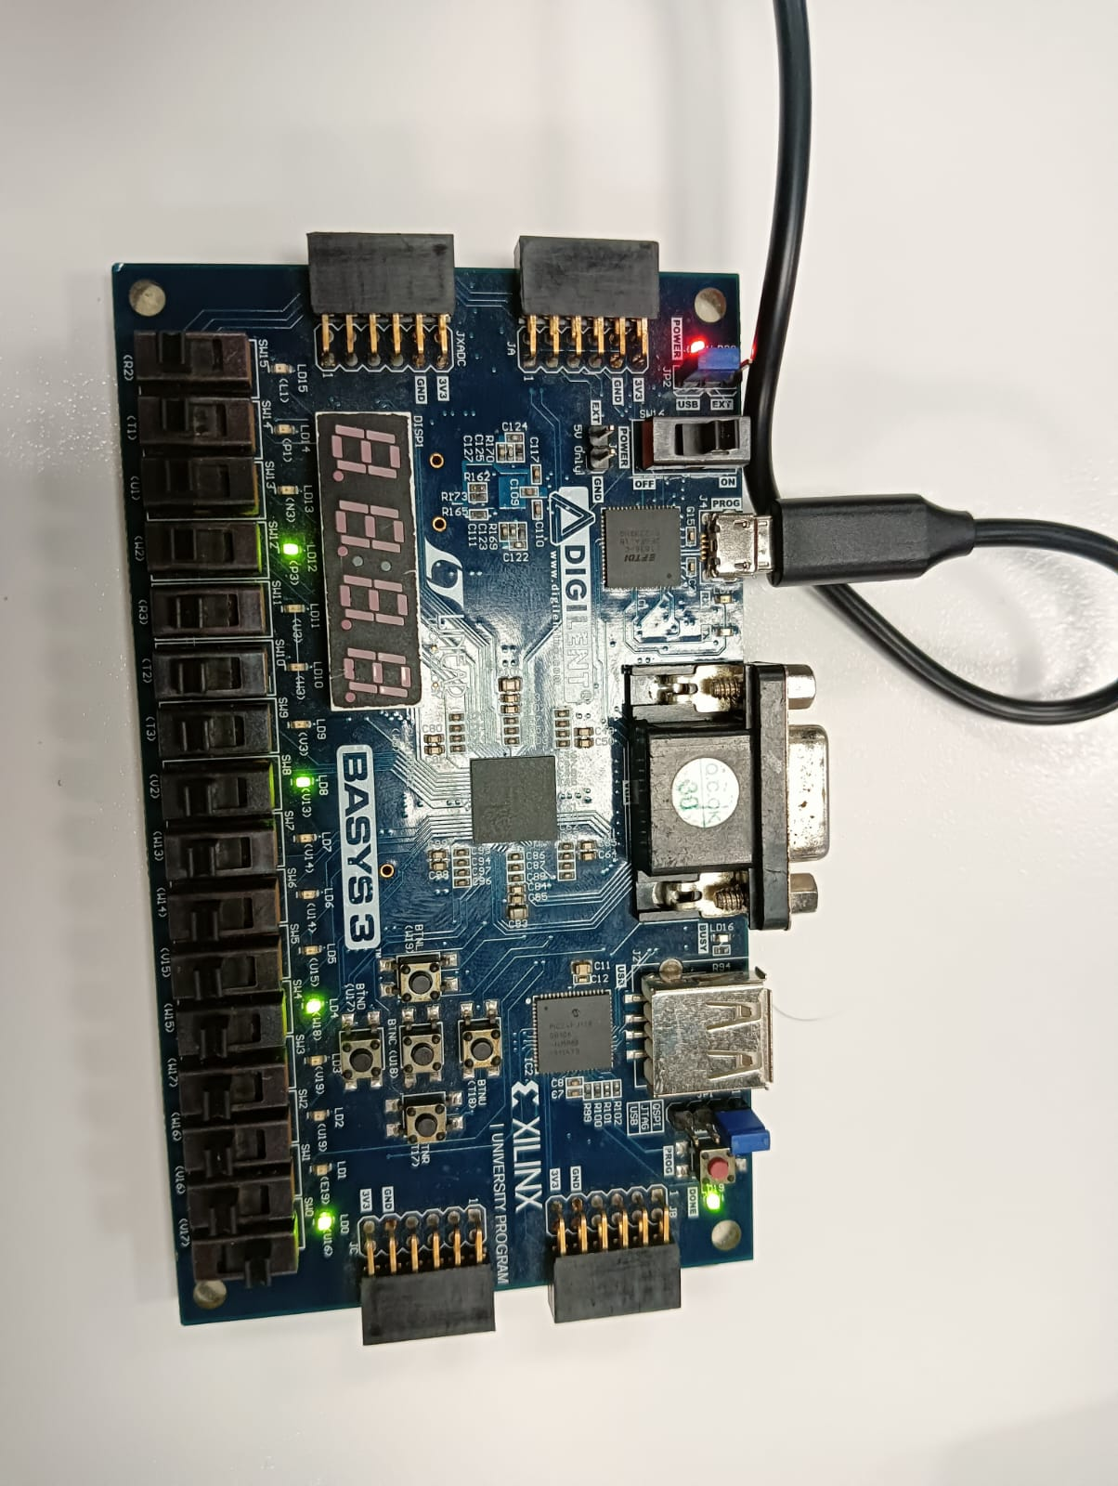
OR: ( 100ns – 170 ns)
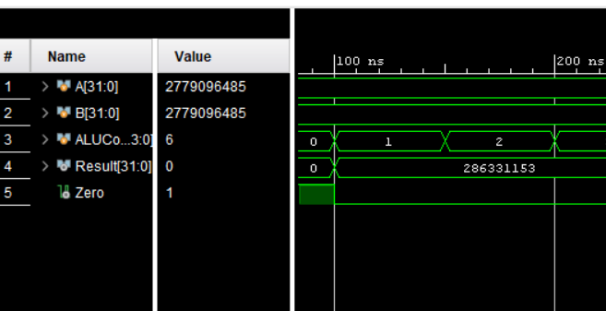

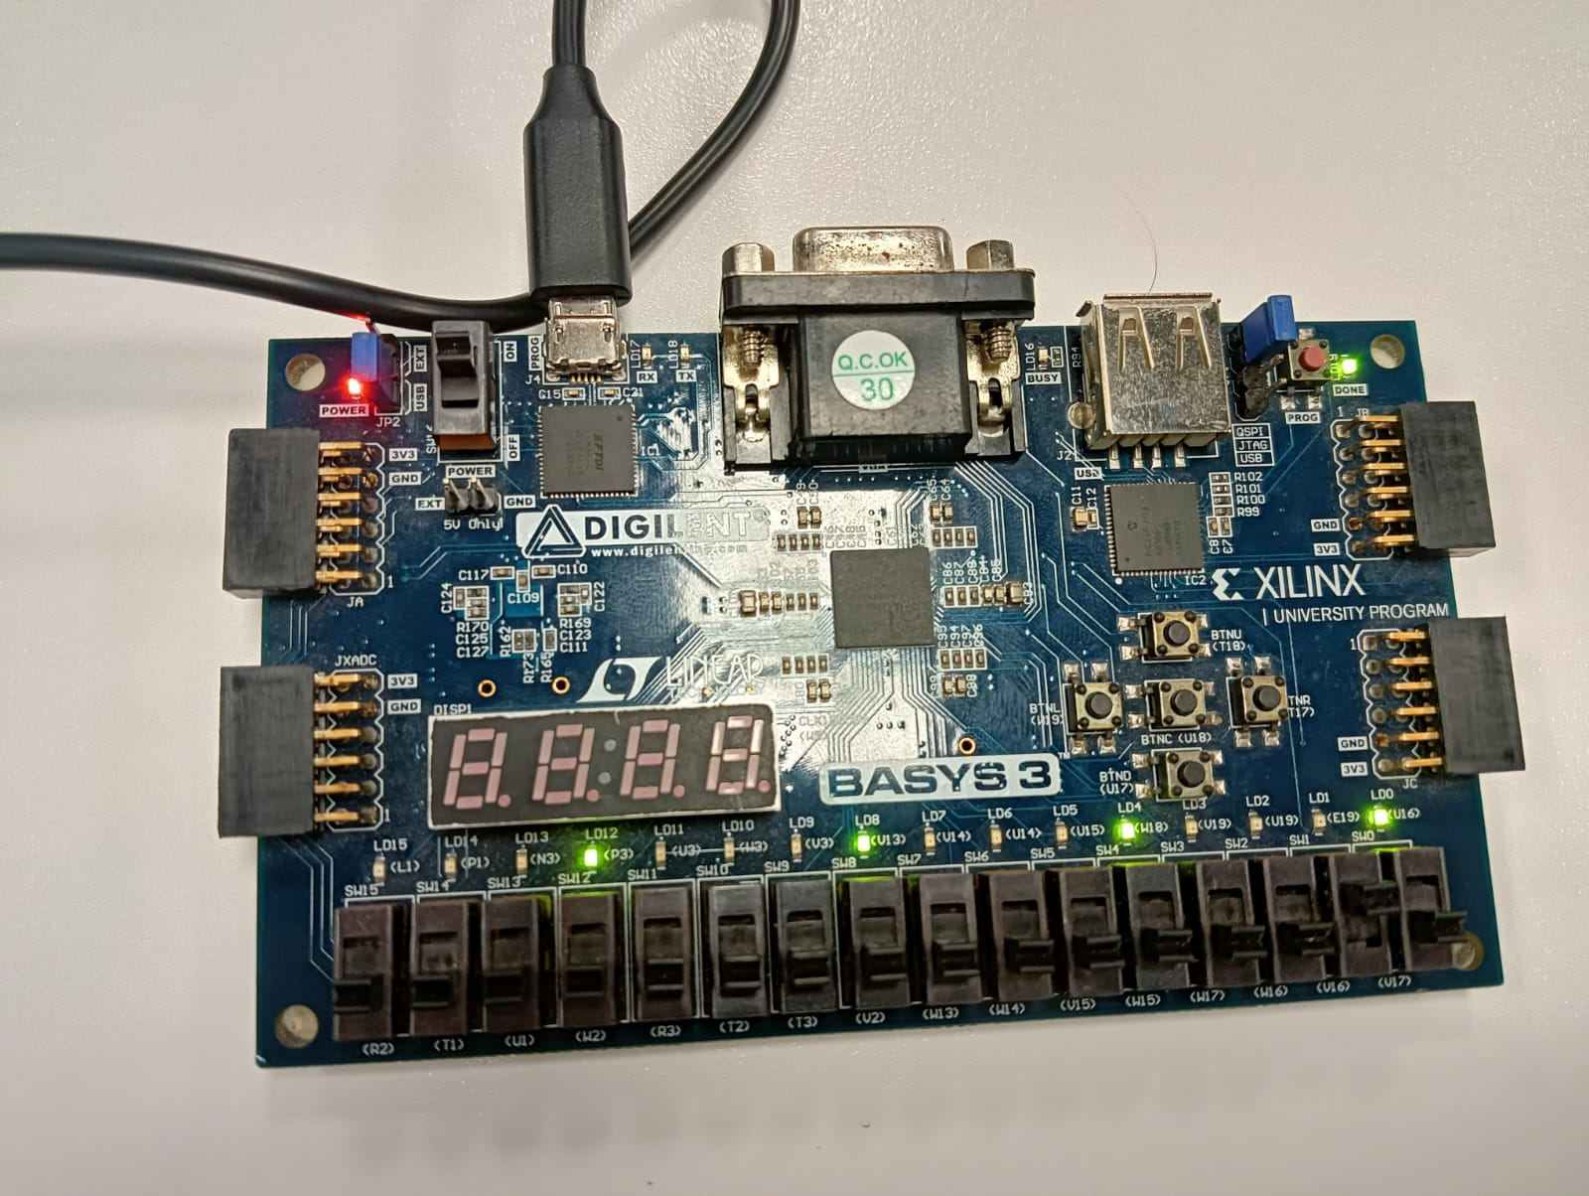

2. OR (ALUControl = 1): Result = 286331153 (0x11111111), Zero flag = 0.

ADD: (170 -200ns)
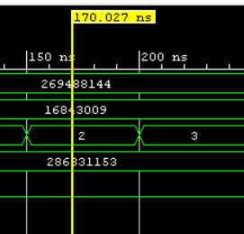

ADD (ALUControl = 2): Result = 286331153 (0x11111111), Zero flag = 0.

XOR: ( 200 – 270 ns )
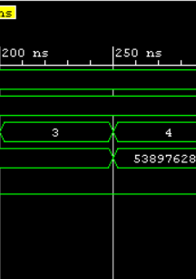

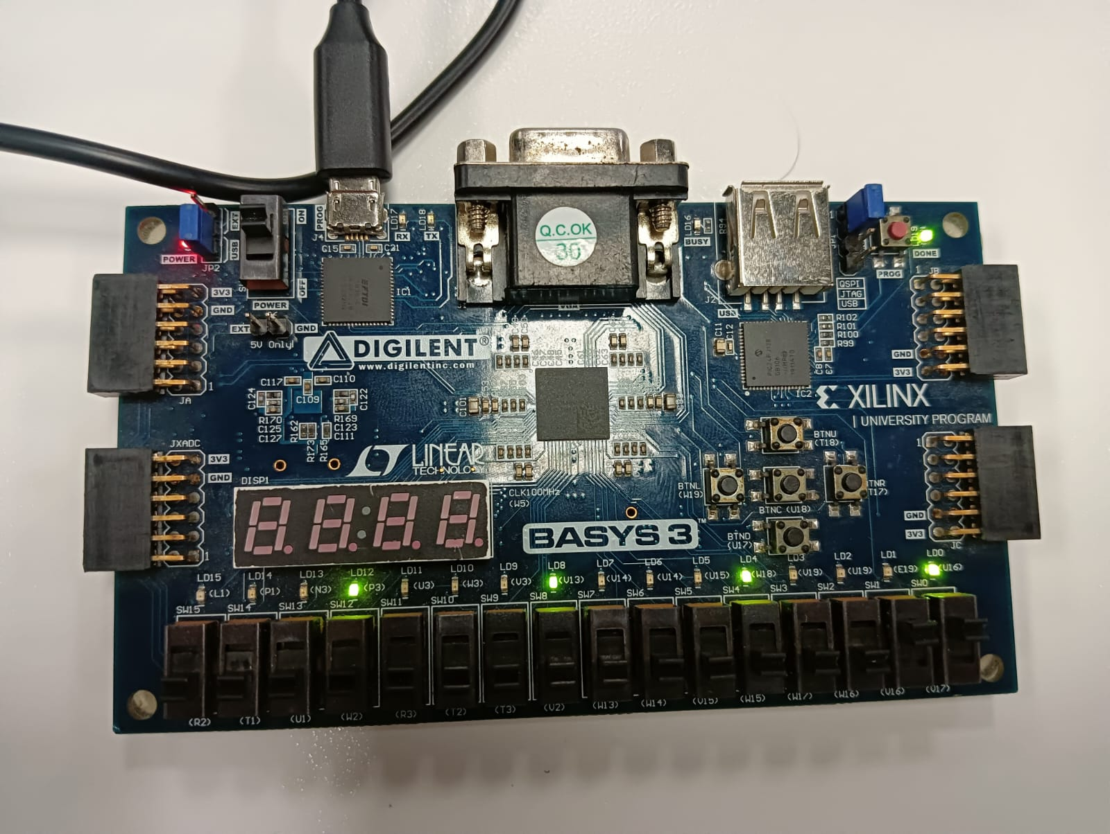
XOR (ALUControl = 3): Result = 286331153 (0x11111111), Zero flag = 0.

SLL: ( 270 – 310 )ns
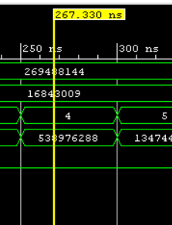

SLL (ALUControl = 4): Shifts A left by B[4:0] (1 bit). Result = 538976288 (0x20202020).
SRL ( 310 – 370 )
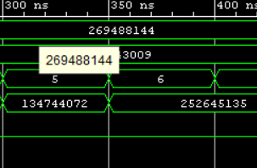

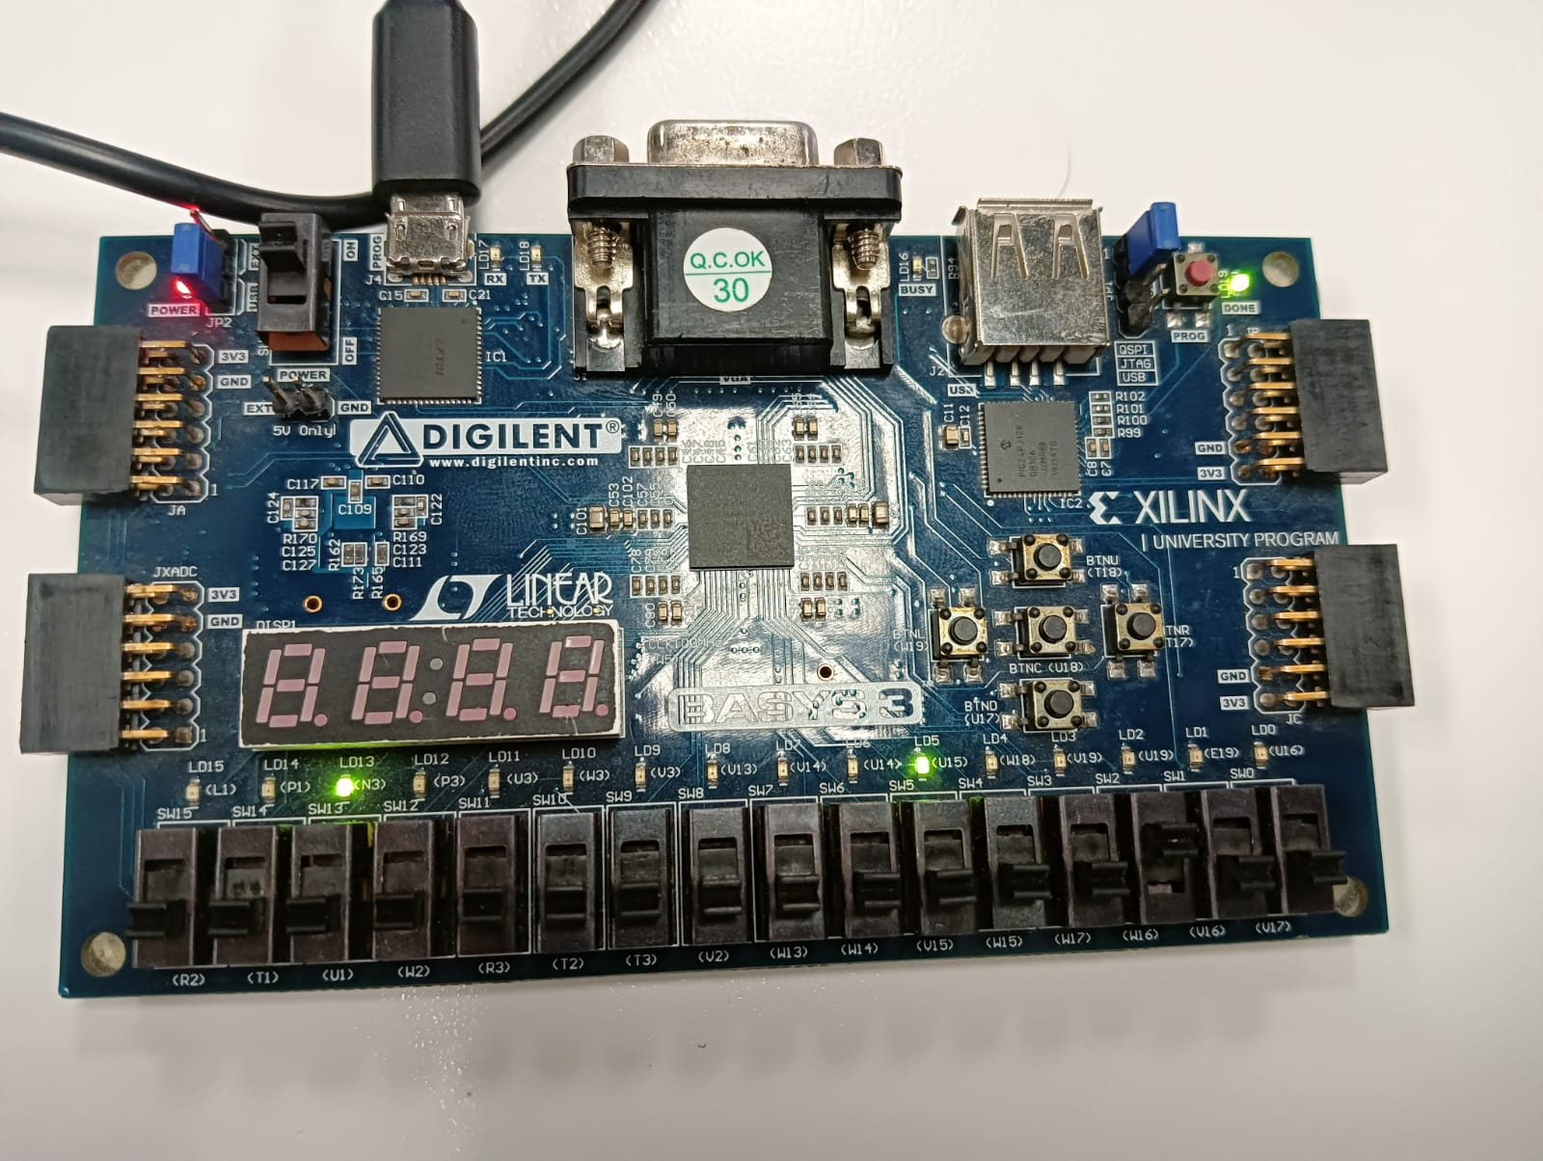

SRL (ALUControl = 5): Shifts A right by B[4:0] (1 bit). Result = 134744072 (0x08080808).
SUB: ( 370 – 420 )ns
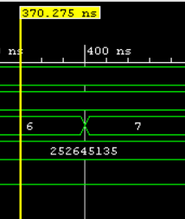

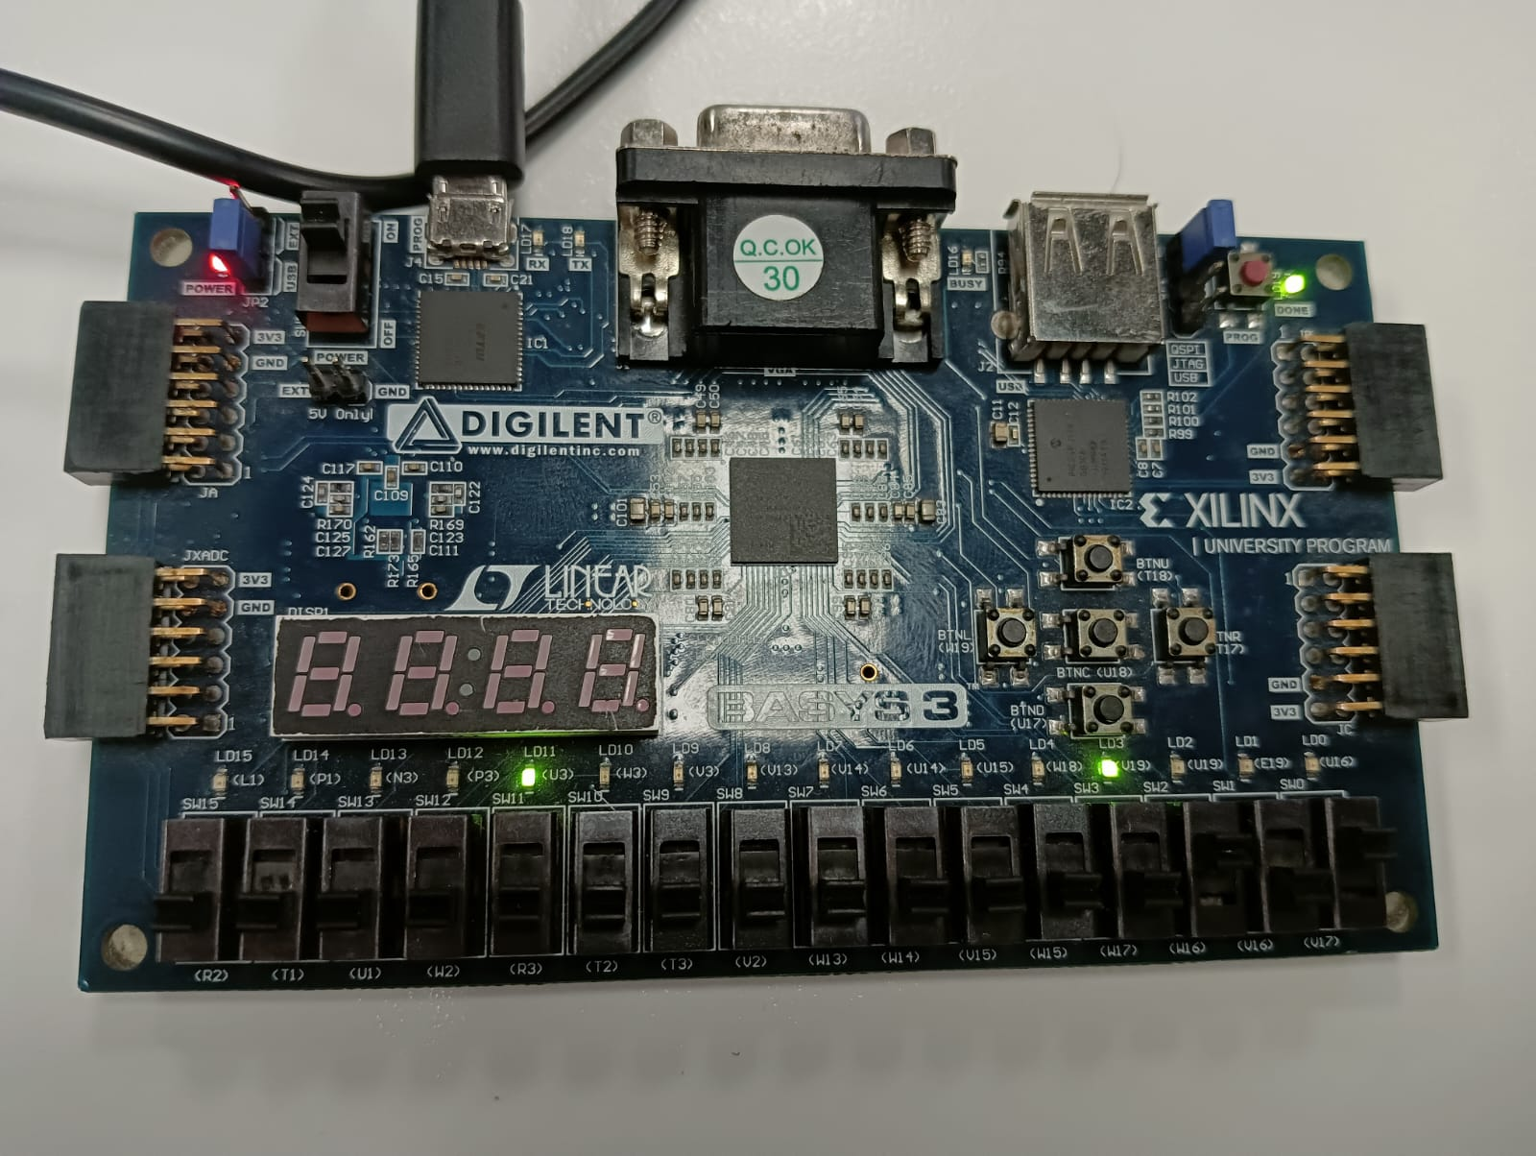

SUB (ALUControl = 6): A - B gives Result = 252645135 (0x0F0F0F0F).
BEQ ( <440 )
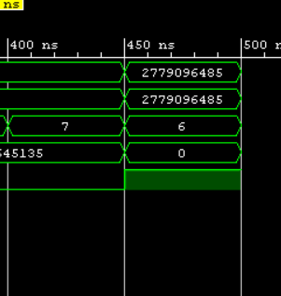

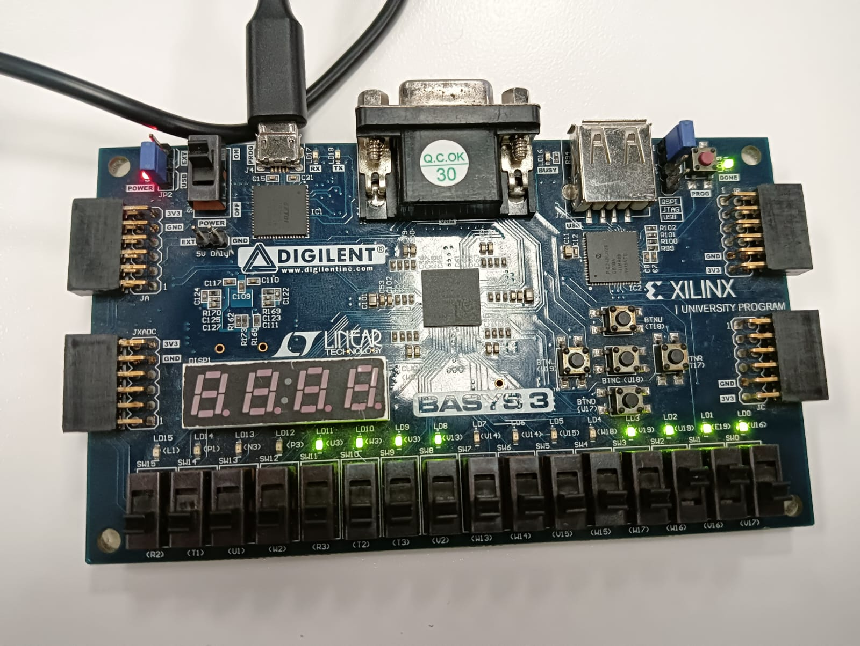

BEQ (ALUControl = 7): Executes subtraction datapath; Result = 252645135 (0x0F0F0F0F).

GithubLink:
https://github.com/MohammadNaqvi1098/CALabs-Git-mn11062.git

Lab 05 – Designing FSM Using FPGA Switches and LEDs

Assessment Rubrics

Points Distribution
Task No. | LR2  Code | LR 5  Results | LR11  Design | AR7
Task 1 | - | - | /20 | /20
Task 2 | /20 | /15 |  | /20
Task 3 | /10 | /15 |  | /20
Total Points | /80 |  |  | /20
CLO Mapped | CLO 1
For description of different levels of the mapped rubrics, please refer the provided Lab Evaluation Assessment Rubrics and Affective Domain Assessment Rubrics.
# | Assessment Elements | Level 1: Unsatisfactory  Points 0-1 | Level 2: Developing  Points 2 | Level 3:Good  Points 3 | Level 4:Exemplary  Points 4
LR2 | Program/Code/ Simulation Model/ Network Model | Program/code/simulation model/network model does not implement the required functionality and has several errors. The student is not able to utilize even the basic tools of the software. | Program/code/simulation model/network model has some errors and does not produce completely accurate results. Student has limited command on the basic tools of the software. | Program/code/simulation model/network model gives correct output but not efficiently implemented or implemented by computationally complex routine. | Program/code/simulation /network model is efficiently implemented and gives correct output. Student has full command on the basic tools of the software.
LR5 | Results & Plots | Figures/ graphs / tables are not developed or are poorly constructed with erroneous results. Titles, captions, units are not mentioned. Data is presented in an obscure manner. | Figures, graphs and tables are drawn but contain errors. Titles, captions, units are not accurate. Data presentation is not too clear. | All figures, graphs, tables are correctly drawn but contain minor errors or some of the details are missing. | Figures / graphs / tables are correctly drawn and appropriate titles/captions and proper units are mentioned. Data presentation is systematic.
AR9 | Report | All the in-lab tasks are not included in report and / or the report is submitted too late. | Most of the tasks are included in report but are not well explained. All the necessary figures / plots are not included. Report is submitted after due date. | Good summary of most the in-lab tasks is included in report. The work is supported by figures and plots with explanations. The report is submitted timely. | Detailed summary of the in-lab tasks is provided. All tasks are included and explained well. Data is presented clearly including all the necessary figures, plots and tables.

